Predictive Modeling for Beauty & Wellness Sales
Classifying High vs. Low Revenue Transactions Using Logistic Regression
Yuva Intern — Data Science Analyst (Beauty & Wellness) | Week 3 Task

1. Introduction to the Predictive Problem
Beauty and wellness businesses handle a large amount of sales data every day, covering different products, countries, and salespeople. Looking at this data can help a business understand which transactions are likely to generate higher revenue. This can support practical decisions such as planning inventory, assigning staff, and focusing marketing efforts on products or regions with stronger sales potential.
In this project, the problem is treated as a binary classification task. Based on details such as the country, product, number of boxes shipped, price per box, and month of sale, the model predicts whether a transaction belongs to the “High Revenue” or “Low Revenue” category. The Cosmetics & Skincare Product Sales dataset contains 374 transaction records and six original attributes: Sales Person, Country, Product, Date, Amount ($), and Boxes Shipped.
The original dataset does not include a High/Low revenue label. Therefore, a new target variable called Revenue_Class was created from the Amount ($) column. A median split was used for this purpose, as explained in the preprocessing section below.

2. Data Preprocessing
Before training the model, the data was checked and prepared through the following steps:
- Missing values: All 374 records were complete across the original columns, so no missing-value treatment or imputation was needed.
- Feature engineering — Price_per_box: A new feature was calculated by dividing Amount ($) by Boxes Shipped. This gives the average price associated with each box and provides useful information about the transaction.
- Feature engineering — Month: The Date column was converted into a datetime format, and the month was extracted from it. This was done to capture possible seasonal patterns without keeping the original high-cardinality date field.
- Target engineering — Revenue_Class: The median Amount ($), which was $6,513.66, was used as the cutoff. Transactions above the median were classified as “High” (1), while transactions at or below the median were classified as “Low” (0). This resulted in a balanced binary target.
- Feature selection: Sales Person, Date, and Amount ($) were removed from the final feature set. Sales Person was left out because the model should be useful for future or unseen salespeople. Date was replaced with the Month feature. Amount ($) was also removed because it was used to create the target; keeping it would introduce data leakage.
- Categorical encoding: Country and Product were converted into one-hot encoded variables. The drop_first=True option was used to avoid the dummy variable trap, resulting in 22 predictor columns.
Preprocessing and feature engineering code:
import pandas as pd
import numpy as np
df = pd.read_csv('cosmetics_sales_data.csv')
print(df.isnull().sum())
df['Price_per_box'] = df['Amount ($)'] / df['Boxes Shipped']
df['Date'] = pd.to_datetime(df['Date'])
df['Month'] = df['Date'].dt.month
median_amount = df['Amount ($)'].median()
df['Revenue_Class'] = np.where(df['Amount ($)'] > median_amount, 'High', 'Low')
df_model = df.drop(columns=['Sales Person', 'Date', 'Amount ($)'])
df_encoded = pd.get_dummies(df_model, columns=['Country', 'Product'], drop_first=True)
df_encoded['Revenue_Class'] = np.where(df_encoded['Revenue_Class'] == 'High', 1, 0)
After preprocessing, the dataset contained 374 rows and 23 columns: 22 predictor features and 1 target column.

3. Methodology and Model Selection
Logistic Regression was chosen as the main model because the target has only two possible outcomes: High Revenue or Low Revenue. It is a useful baseline for binary classification and also makes the effect of individual features easier to interpret. It is appropriate for a dataset of this size and does not require extensive tuning to produce a useful starting model.
Other approaches were also considered. Linear Regression was not suitable because it is designed for predicting continuous values rather than class labels. Decision Trees could have been used as another option, but they can overfit relatively small datasets if they are not properly pruned or combined with other models.
The data was divided into 80% training data (299 records) and 20% testing data (75 records). Stratified sampling was used so that the High and Low classes remained similarly represented in both sets.
from sklearn.model_selection import train_test_split
from sklearn.linear_model import LogisticRegression
X = df_encoded.drop(columns=['Revenue_Class'])
y = df_encoded['Revenue_Class']
X_train, X_test, y_train, y_test = train_test_split(
X, y, test_size=0.2, random_state=42, stratify=y
)
model = LogisticRegression(max_iter=1000, random_state=42)
model.fit(X_train, y_train)

4. Model Parameters
- test_size = 0.2 — 20% of data reserved for testing, 80% for training
- stratify = y — preserves the High/Low class ratio identically across train and test splits
- random_state = 42 — fixes the random seed for reproducible splits and results
- max_iter = 1000 — allows the solver sufficient iterations to converge given 22 input features
- Solver: default (lbfgs), suitable for the dataset size and L2-regularized logistic regression used here

5. Validation and Performance Metrics
The model was checked using 5-fold cross-validation on the training data. It was then evaluated on the separate test set using accuracy, precision, recall, F1-score, a confusion matrix, and an ROC curve with the AUC score. These measures give a more complete view of how well the model performs rather than relying on accuracy alone.
from sklearn.model_selection import cross_val_score
from sklearn.metrics import (accuracy_score, classification_report,
confusion_matrix, ConfusionMatrixDisplay, roc_curve,
roc_auc_score, RocCurveDisplay)
cv_scores = cross_val_score(model, X_train, y_train, cv=5, scoring='accuracy')
y_pred = model.predict(X_test)
y_proba = model.predict_proba(X_test)[:, 1]
test_accuracy = accuracy_score(y_test, y_pred)
print(classification_report(y_test, y_pred, target_names=['Low', 'High']))
cm = confusion_matrix(y_test, y_pred)
auc_score = roc_auc_score(y_test, y_proba)
Cross-validation and test set results:
Metric | Value
5-Fold CV Accuracy Scores | 0.933, 0.967, 0.917, 0.983, 0.966
Mean CV Accuracy | 0.9532 (95.3%)
CV Standard Deviation | 0.0244 (2.4%)
Test Set Accuracy | 0.8933 (89.3%)
ROC-AUC Score | 0.9836

Classification report (test set):
Class | Precision | Recall | F1-Score | Support
Low (0) | 0.92 | 0.87 | 0.89 | 38
High (1) | 0.87 | 0.92 | 0.89 | 37
Accuracy |  |  | 0.89 | 75
Macro Avg | 0.89 | 0.89 | 0.89 | 75
Weighted Avg | 0.89 | 0.89 | 0.89 | 75

6. Visualizations
The confusion matrix shows that the model correctly classified 33 of the 38 Low Revenue transactions and 34 of the 37 High Revenue transactions in the test set. There were 5 false positives and 3 false negatives.
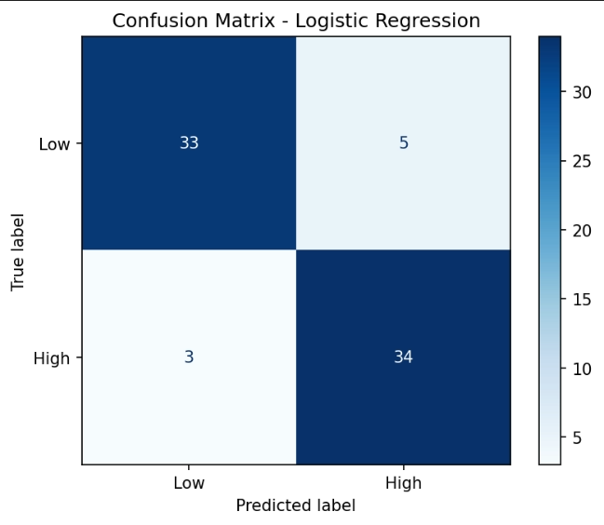
Figure 1: Confusion Matrix — Logistic Regression
The ROC curve moves close to the top-left corner and gives an AUC of 0.98. This indicates that the model is able to distinguish between High and Low Revenue transactions very effectively across different classification thresholds.
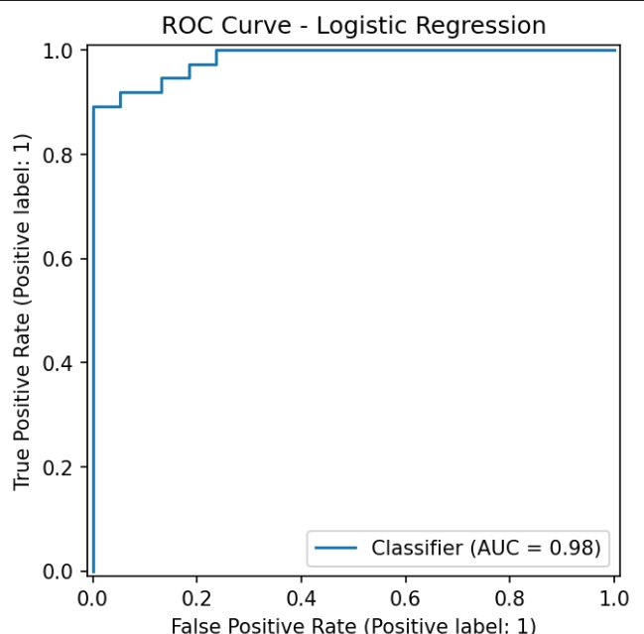
Figure 2: ROC Curve — Logistic Regression (AUC = 0.98)

7. Critical Analysis of Model Results
Overall, the model performed well on this dataset. The average 5-fold cross-validation accuracy was 95.3%, while the test accuracy was 89.3%. The cross-validation standard deviation was only 2.4%, which suggests that the model gave fairly consistent results across the different folds. The difference between the cross-validation and test accuracy may mainly be due to the relatively small test set of 75 records.
The precision and recall values are also fairly balanced, ranging from 0.87 to 0.92 for the two classes. This suggests that the model is not strongly biased toward predicting one class more than the other. The very high ROC-AUC score of 0.984 also shows strong separation between High and Low Revenue transactions.
However, there is an important limitation to consider. Boxes Shipped and Price_per_box are closely connected to the Amount ($) value used to create the target, because Amount ($) = Boxes Shipped × Price_per_box. As a result, the strong model performance is partly explained by this mathematical relationship and may not represent a deeper customer or business behavior pattern. In addition, the dataset contains only 374 rows from a single year (2022), so the model may not generalize as well to future years or new markets. The 5 false positives and 3 false negatives also show that the model can still make mistakes, especially for transactions close to the median cutoff.

8. Potential Improvements
- Collect more sales data from multiple years so that the model can learn from wider seasonal and long-term patterns.
- Compare Logistic Regression with models such as Random Forest and Gradient Boosting to see whether they can capture non-linear relationships between Country, Product, and other features.
- Use hyperparameter tuning, such as GridSearchCV, to find a suitable regularization strength (C) for Logistic Regression.
- Try different ways of defining the target, such as using tertiles instead of a median split, to check whether more detailed revenue categories provide additional business value.
- If the required data is available, include more realistic business features such as marketing spend, customer demographics, and seasonality indicators instead of relying only on transaction-level information.

9. Conclusion
A Logistic Regression model was successfully developed to classify transactions as High or Low Revenue in the beauty and wellness sales dataset. The model achieved 89.3% accuracy on the test set and a strong ROC-AUC of 0.984. The project covers the complete predictive modeling process, including data preprocessing, feature engineering, model training, cross-validation, and evaluation. The results show that this approach can be useful for identifying potentially high-value transactions and supporting business decisions in the beauty and wellness sector.

